Recruitment Test:

Ifza Shad Technical Assignment

Q2.

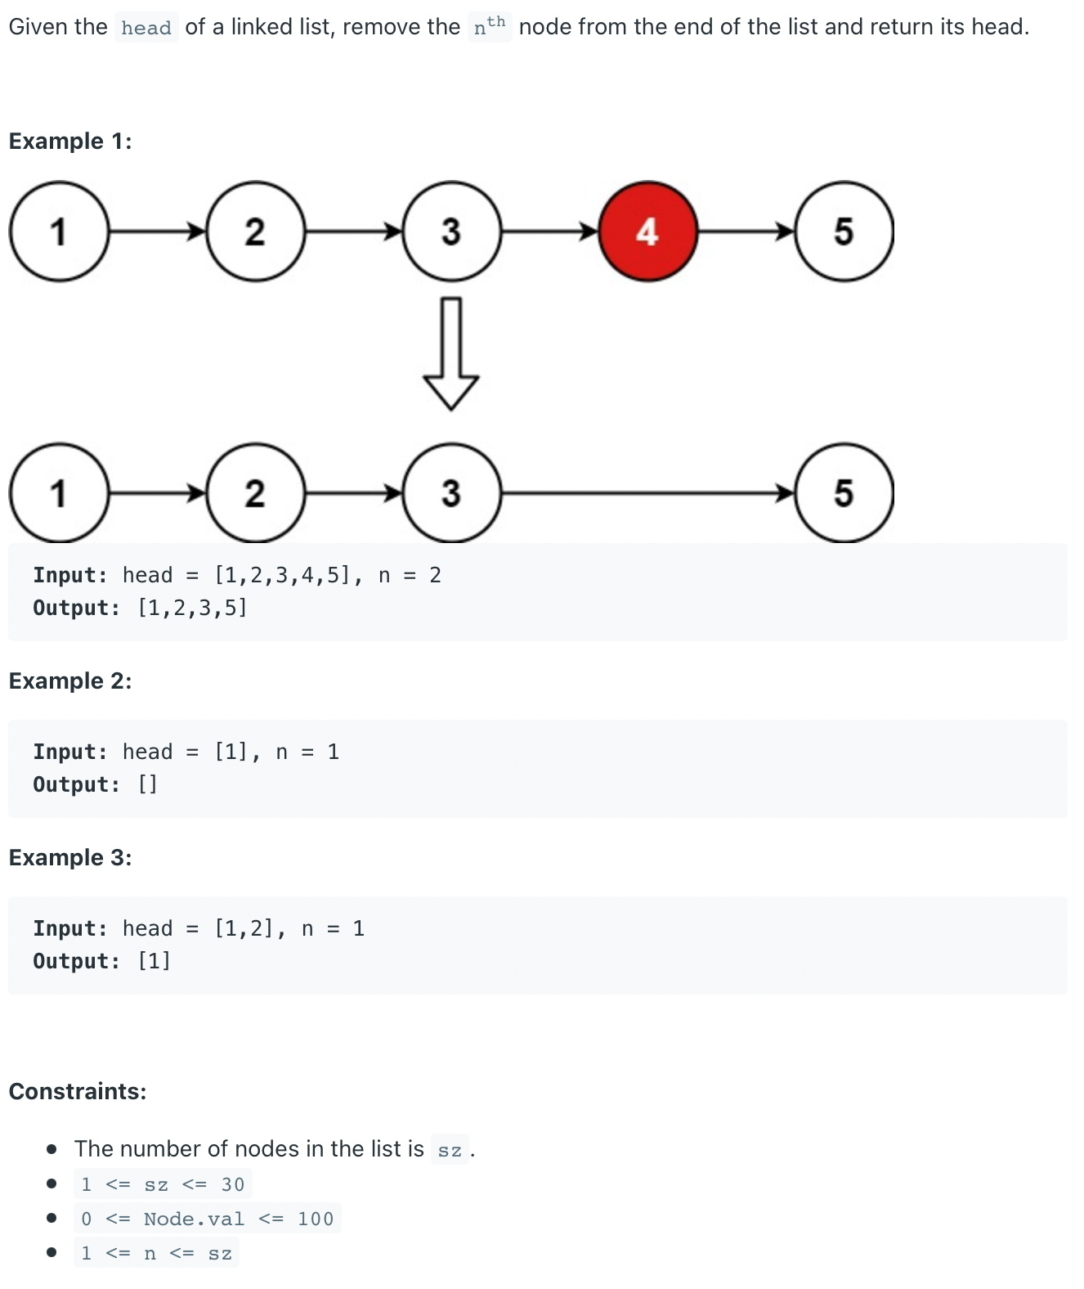

Solution:

ListNode removeNodefromEnd( ListNode head, int N)

{

If(head == Null)

Return Null

Int lenghtcount=0

ListNode temp= head

While (temp !Null)

{

lengthcount = lengtcount+1

Temp = temp -> next

}

Lengthcount = lengthcount – N

if (lengthcount = = 0)

{

temp = head -> next

head -> next= Null

delete (head)

return temp

}

listnode curr= head

listnode prev = Null

While (lenghtcount > 0)

{

prev= curr

curr= curr-> next

lenghtcount = lengthcount – 1

}

prev -> next =curr->next

curr-> next= Null

delete (curr)

return head

}